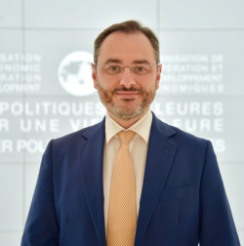
Mr. Federico Bonaglia is the Deputy Director of the OECD Development Centre.
In this capacity, Federico supports the Director in establishing the strategic directions and implementing the Programme of Work of the Development Centre, ensuring that the Centre’s analysis and advice remain at the forefront of policy thinking and produce results.
He provides leadership to strengthen the Development Centre’s engagement with its member countries, notably by managing the Centre’s Governing Board, and to increase the impact of the Centre’s work.
In particular, Federico oversees the Development Centre’s work with Africa, Asia and Latin America and the Caribbean, as well as the multi-dimensional country-reviews and thematic areas of work such as migration and development, urbanisation and territorial development. Federico is also the Head of Delegation for the OECD to the G20 development working group.
An economist by training, graduated in Economics and Social Sciences (Discipline Economiche e Sociali) from Bocconi University and with a master in economics from the same University, Federico joined the OECD Development Centre in 1999. At the OECD, he has been involved and led several projects on the economic and institutional consequences of globalisation for developing countries in Africa, South-East Asia, Central America, the Black Sea and Central Asia regions.
In 2008-09, he was loaned to the Italian Prime Minister’s Office to lead the development and outreach aspects of the G8 Sherpa office for the La Maddalena-Aquila Leaders’ Summit.

